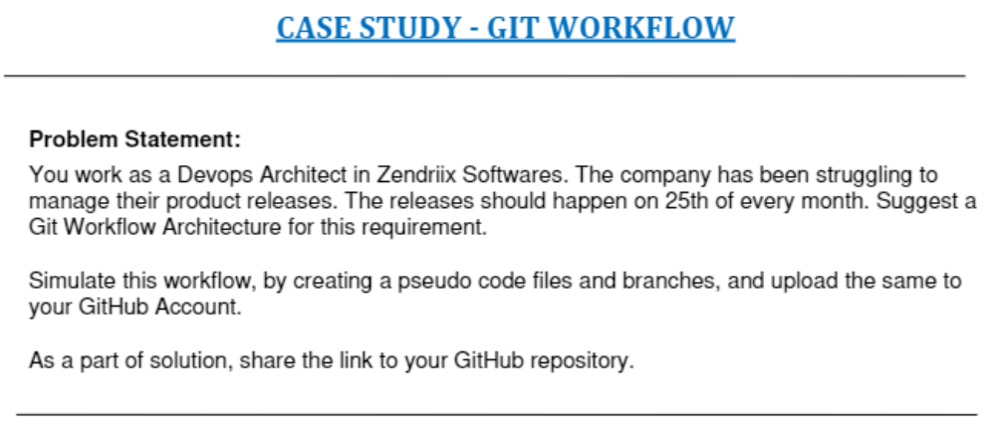
ubuntu@ip-172-31-25-3:~$ mkdir casestudy1
ubuntu@ip-172-31-25-3:~$ cd casestudy1/
ubuntu@ip-172-31-25-3:~/casestudy1$ git init
Initialized empty Git repository in /home/ubuntu/casestudy1/.git/
ubuntu@ip-172-31-25-3:~/casestudy1$ touch pseudo1.txt
ubuntu@ip-172-31-25-3:~/casestudy1$ git add .
ubuntu@ip-172-31-25-3:~/casestudy1$ git commit -m "case study first commit"
[master (root-commit) dbc1311] case study first commit
1 file changed, 0 insertions(+), 0 deletions(-)
create mode 100644 pseudo1.txt
ubuntu@ip-172-31-25-3:~/casestudy1$ git branch
* master
ubuntu@ip-172-31-25-3:~/casestudy1$ git branch develop
ubuntu@ip-172-31-25-3:~/casestudy1$ git branch feature1
ubuntu@ip-172-31-25-3:~/casestudy1$ git branch feature2
ubuntu@ip-172-31-25-3:~/casestudy1$ git branch
develop
feature1
feature2
* master
ubuntu@ip-172-31-25-3:~/casestudy1$ git checkout develop
Switched to branch 'develop'
ubuntu@ip-172-31-25-3:~/casestudy1$ ls
pseudo1.txt
ubuntu@ip-172-31-25-3:~/casestudy1$ git checkout feature1
Switched to branch 'feature1'
ubuntu@ip-172-31-25-3:~/casestudy1$ touch feature1.txt
ubuntu@ip-172-31-25-3:~/casestudy1$ git add .
ubuntu@ip-172-31-25-3:~/casestudy1$ git commit -m "feature1 first commit"
[feature1 4588c60] feature1 first commit
1 file changed, 0 insertions(+), 0 deletions(-)
create mode 100644 feature1.txt
ubuntu@ip-172-31-25-3:~/casestudy1$ ls
feature1.txt pseudo1.txt
ubuntu@ip-172-31-25-3:~/casestudy1$ git checkout feature2
Switched to branch 'feature2'
ubuntu@ip-172-31-25-3:~/casestudy1$ ls
pseudo1.txt
ubuntu@ip-172-31-25-3:~/casestudy1$ touch feature2.txt
ubuntu@ip-172-31-25-3:~/casestudy1$ git add .
ubuntu@ip-172-31-25-3:~/casestudy1$ git commit -m "feature2 first commit"
[feature2 0f84b17] feature2 first commit
1 file changed, 0 insertions(+), 0 deletions(-)
create mode 100644 feature2.txt
ubuntu@ip-172-31-25-3:~$ cd casestudy1/
ubuntu@ip-172-31-25-3:~/casestudy1$ git branch
develop
feature1
* feature2
master
ubuntu@ip-172-31-25-3:~/casestudy1$ git checkout develop
Switched to branch 'develop'
ubuntu@ip-172-31-25-3:~/casestudy1$ git merge feature1
Updating dbc1311..4588c60
Fast-forward
feature1.txt | 0
1 file changed, 0 insertions(+), 0 deletions(-)
create mode 100644 feature1.txt
ubuntu@ip-172-31-25-3:~/casestudy1$ git merge feature2
Merge made by the 'recursive' strategy.
feature2.txt | 0
1 file changed, 0 insertions(+), 0 deletions(-)
create mode 100644 feature2.txt
ubuntu@ip-172-31-25-3:~/casestudy1$ ls
feature1.txt feature2.txt pseudo1.txt
ubuntu@ip-172-31-25-3:~/casestudy1$ git branch
* develop
feature1
feature2
master
ubuntu@ip-172-31-25-3:~/casestudy1$ git checkout master
Switched to branch 'master'
ubuntu@ip-172-31-25-3:~/casestudy1$ git merge master
Already up to date.
ubuntu@ip-172-31-25-3:~/casestudy1$ git merge develop
Updating dbc1311..6c2b415
Fast-forward
feature1.txt | 0
feature2.txt | 0
2 files changed, 0 insertions(+), 0 deletions(-)
create mode 100644 feature1.txt
create mode 100644 feature2.txt
ubuntu@ip-172-31-25-3:~/casestudy1$ ls
feature1.txt feature2.txt pseudo1.txt
ubuntu@ip-172-31-25-3:~$ cd casestudy1/
ubuntu@ip-172-31-25-3:~/casestudy1$ git remote add origin git@github.com:vcgatate/Git-casestudy1.git
ubuntu@ip-172-31-25-3:~/casestudy1$ git branch
develop
feature1
feature2
* master
ubuntu@ip-172-31-25-3:~/casestudy1$ git push origin master
Enumerating objects: 9, done.
Counting objects: 100% (9/9), done.
Compressing objects: 100% (7/7), done.
Writing objects: 100% (9/9), 827 bytes | 827.00 KiB/s, done.
Total 9 (delta 2), reused 0 (delta 0)
remote: Resolving deltas: 100% (2/2), done.
To github.com:vcgatate/Git-casestudy1.git
* [new branch] master -> master
ubuntu@ip-172-31-25-3:~/casestudy1$ git push -f origin --all
Total 0 (delta 0), reused 0 (delta 0)
To github.com:vcgatate/Git-casestudy1.git
* [new branch] develop -> develop
* [new branch] feature1 -> feature1
* [new branch] feature2 -> feature2
